User Guide

Thanks for choosing ABC inventory system.

This document is to provide guidance to our inventory system.

General operation:

1. Follow the instruction shown on the screen to input right data, press <Enter> to finish an input attempt.
2. The system will check if the input data is appropriate for the required operation, and will let you do it again if you type something illegal.
3. Explanation about order status:

|  |  |
| --- | --- |
| Status | detail |
| Established | Order has just been created, no allocate attempt yet. |
| Under allocate | Order has partly been allocated. |
| In stock | Order has been fully allocated and socked in the warehouse |
| Under remove | Order has begin removing, but not finish yet. |
| Finished | Remove operation has been finished. Whole process has done. |

For customer:

1. As a customer, you will have to register before using this system.

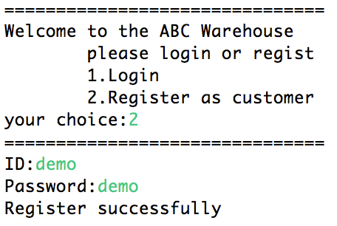

As shown in the picture above, choice 2 to begin a register process.If register successfully, the system will redirect you to an login process automatically.

1. After register, or if you’ve already had an account, you can now login to our system

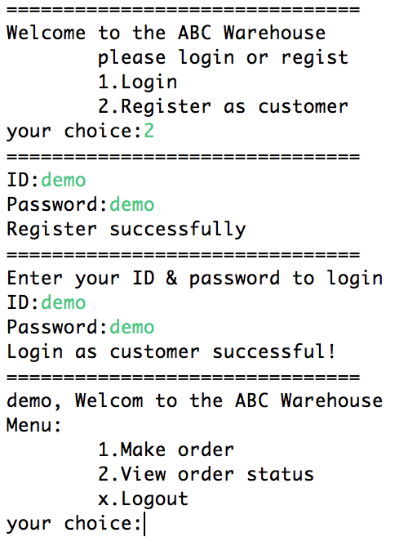

The picture above shows the whole process of register, login and the customer menu.

1. In customer menu, you can either to make order or to view current orders’ status.
   1. For making order, you need to input the amount of items;

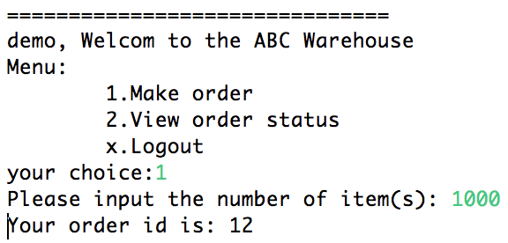

As shown in the picture above, we made an order contains 1000 items.Also the system will show you the ID of the new order.

* 1. Viewing order status will give you a new menu and you can choose to:
     1. Show all your orders’ status
     2. Show a specific order’s status by give the order ID.

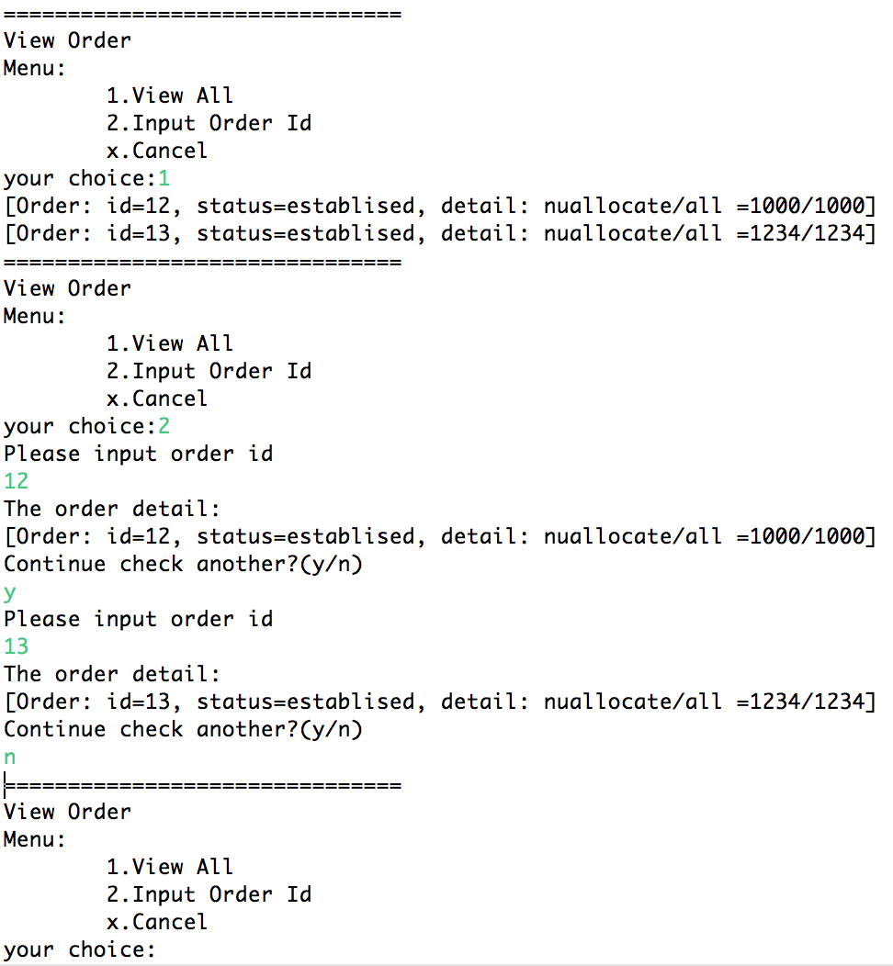

In the picture, the 1st part shows view all orders’ status of this user, the 2nd part shows view specific order’s status, and you can choose whether to continue check another or not by agree (y, yes, ok), or disagree (n, no).

1. You can log out when you finish your operations.

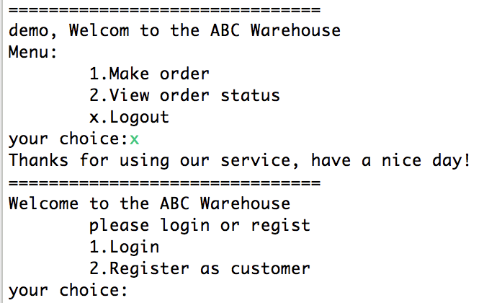

For administrator:

1. The administrator account is now hard code in the system, as required by the company, both of them are “admin”, please note: there is one and only one administrator in the system, and there is no way to register as an administrator.
2. Login as the administrator, the system turns to the administrator menu(as shown below).

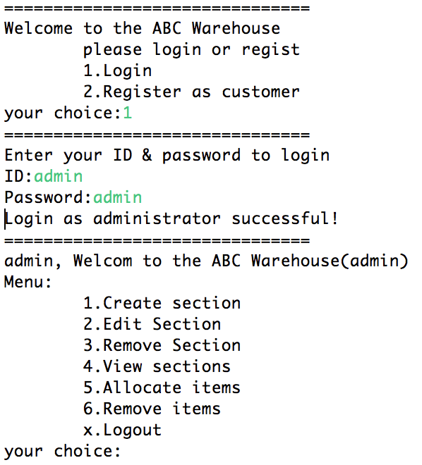

1. There are five functions for administrator:
   1. Add section:

You can add a new section with certain capacity. The capacity is required to enter when you add a new section. The number you enter indicates the number of pallet(s) in this section. Every pallet can hold 75 items;

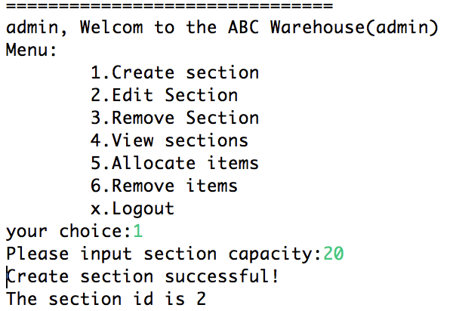

The picture above shows the whole process of create section, if successful, the new section id will be shown on the screen.

* 1. Edit section:

You can edit a section to change the capacity (the number of pallets in this section). The section can be changed to higher capacity without error. But if you want to change to a lower capacity than current used capacity, the system will prompt error message.

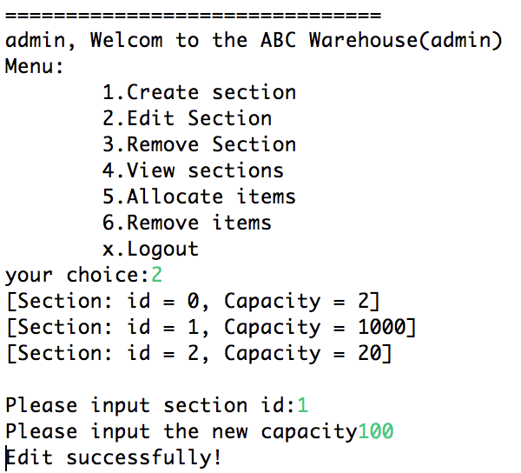

* 1. Remove section:

You can choose to remove certain section. If the section is empty, the operation will succeed. If the section is storing items now, the system will show error information.

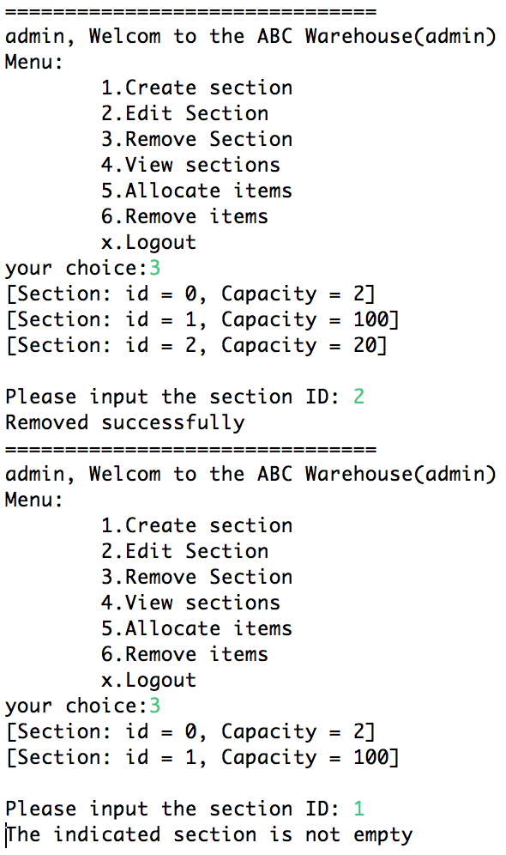

* 1. View sections:

The administrator can view detailed info of all sections.

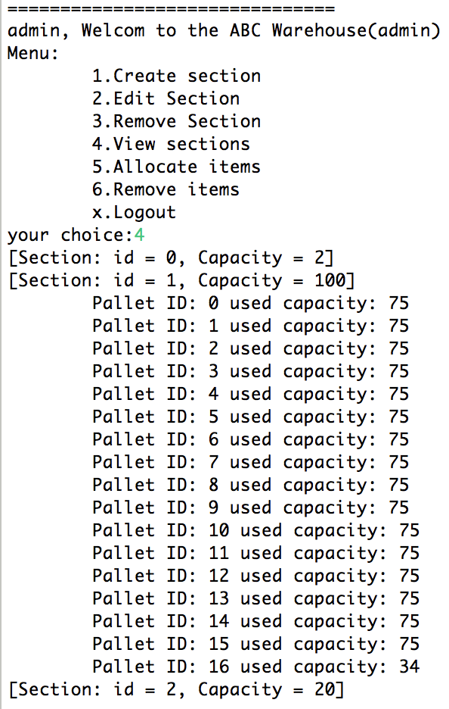

* 1. Allocate items:

When you choose allocate item option in the menu, the interface will show all orders in the system. Then you can enter the ID of the order to be allocated. The system will allocate the items of this order to available section automatically.

If anything goes wrong, simply follow the instruction shown on the screen.

The rules for allocate operation is in appendix.

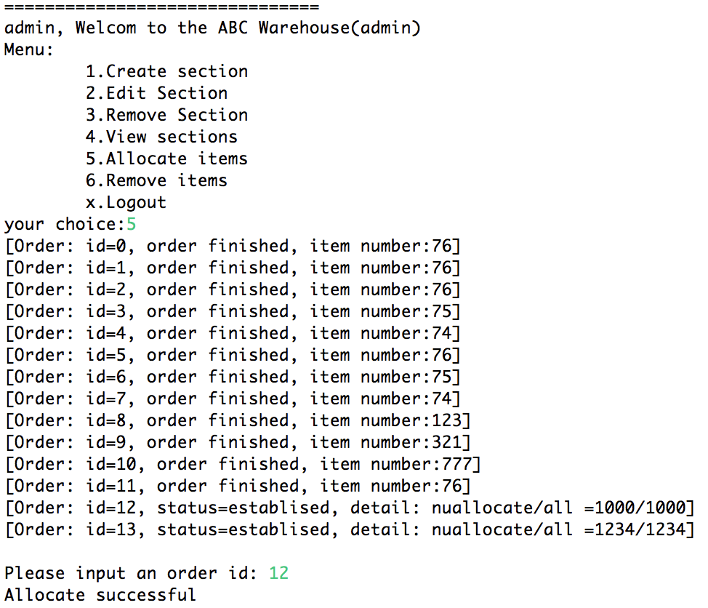

* 1. Remove items:

Similar to the allocate item, the administrator simply input the order id, and the system will remove the specific order for you.

If anything goes wrong, simply follow the instruction shown on the screen.

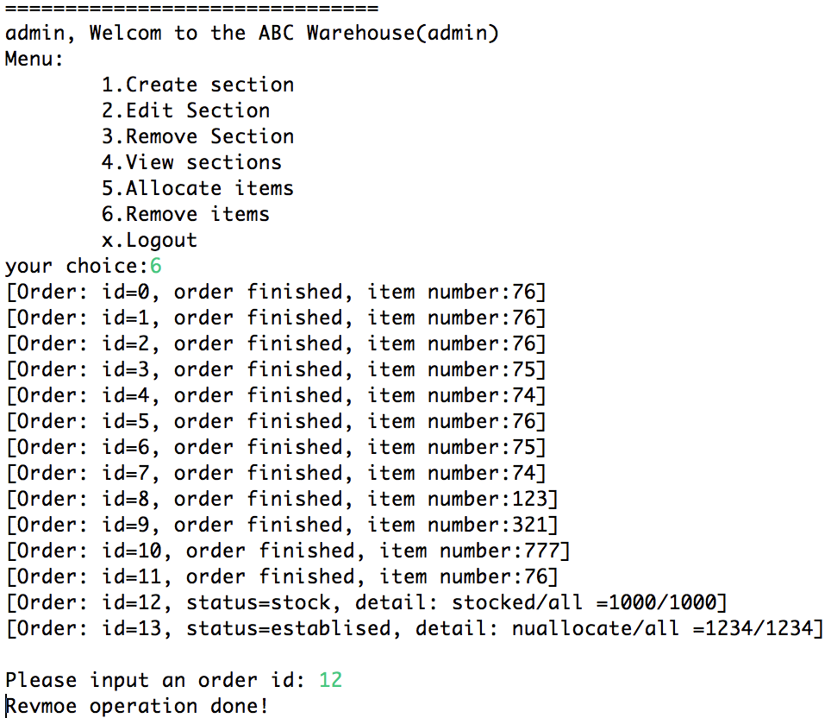

Appendix

Allocate rules:

First, try to fill the pallet that belongs to the customer for the specific user.

Second, if not enough, to allocate the order with in least sections, in other words, allocate the order to the sections from the one has biggest free space to the one has least free space.

Finally, there is no free space to allocate more item in the system, an message with the least pallet number will be shown on the screen.